Now let's look at how we can use a combination of fields and tables to be passed into a subroutine at the same time.



So, you can see this is a combination of the first two perform statements all combined into one to allow us to use a mix of fields and tables.

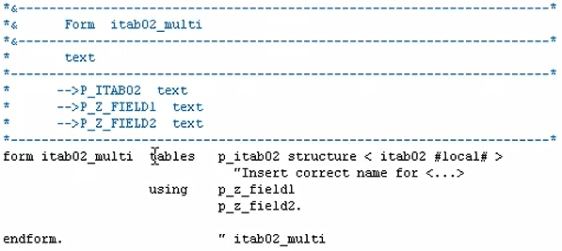

And you can see the form has been defined. We have the table statement, and then we have the using statement for the fields.

Now as I mentioned before, if you're manually creating your, perform statements, make sure you get the sequence of fields correct, that you defined.

So, for example, if we had this, you know, mixed around, z field2 going to, z field2 then z field1. Things will get mixed up, and we will be putting z field2 into this local variable, and z field1 into this one.x